The EU Deforestation Regulation: The EUDR What Businesses Need to Know Before 2026
oliver7520
Sep 16, 2025
3 min read
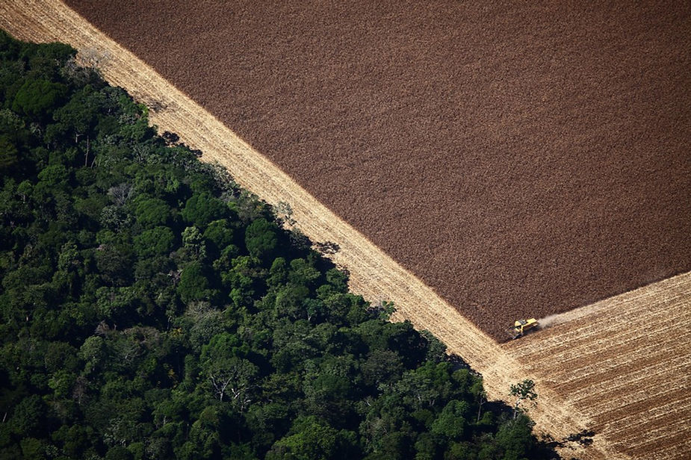
View of a Combine working in agricultural land in Santa Carmem, Mato Grosso, Brazil.
The EU Deforestation Regulation (EUDR), coming into effect at the end of 2025, will replace the existing EU Timber Regulation, setting a much higher bar for the trade of commodities associated with deforestation. Companies trading in wood, rubber, cattle, coffee, cocoa, soy, and palm oil, along with derived products, should be preparing now for what is one of the most ambitious sustainability measures of the decade.

Why Is the EUDR Needed?

The EU’s own consumption is estimated to account for roughly 16% of deforestation linked to international trade, according to WWF figures, making it the second-largest driver of tropical deforestation after China. Between 1990 and 2020, approximately 420 million hectares of forest-an area larger than the EU itself-were lost worldwide, primarily due to agriculture, logging, and the expansion of commodity supply chains. By targeting products placed on or exported from the EU market, EUDR aims not only to reduce the communities direct footprint but also to help lower global greenhouse gas emissions by over 30 million tonnes per year.

New Measures and Business Obligations

From December 2025, companies will no longer be able to trade relevant goods in the EU without first submitting a Due Diligence Statement, publicly declaring that products are both deforestation-free and produced legally under the laws of their country of origin. Businesses must now undertake strict due diligence, including geolocation documentation of the land where commodities were produced, risk assessments, and credible traceability procedures. Operators and traders will also be expected to use the EU’s new information system for regulatory submissions and ensure all actors in the chain of custody are compliant. For organisations used to patchwork compliance systems, this represents a major operational and technological shift.

Simplifications and Clarifications

Recognising the scale of the compliance burden, the European Commission has proposed a number of simplifications. Notably, there is now the capacity to reuse Due Diligence Statements for repeat or regular shipments, and group companies may submit on behalf of affiliates. Updates to the guidance have also clarified the circumstances under which businesses must submit annual versus consignment-specific reporting, with an emphasis on proportionality and risk-based targeting. This is intended to help SMEs and complex, multi-jurisdictional operators avoid unnecessary duplication and costs, while still holding high environmental standards front and centre. Additionally, to confirm that another supply chain entity has already completed due diligence on relevant commodities, companies should at least collect the Due Diligence Statement (DDS) reference and verification numbers from upstream partners and verify their validity through the EU Information System. Leaflets, catalogues, marketing materials, samples of negligible value, waste, and packaging are explicitly excluded from the scope of the EUDR and are not subject to its due diligence requirements.

Unintended Consequences and Drawbacks

Despite the EUDR's noble environmental objectives, several significant unintended consequences could undermine its effectiveness and create substantial challenges for both the EU and commodity producers. Market leakage poses perhaps the greatest risk, with research indicating that producers may simply redirect deforestation-linked commodities to unregulated markets rather than incur compliance costs. Ecosystem spillover represents another critical concern, as the regulation's exclusive focus on forests could inadvertently push agricultural expansion into unregulated ecosystems like Brazil's carbon-rich Cerrado savanna, potentially causing even greater environmental damage. The regulation also risks creating a small holder blind spot, potentially excluding millions of small-scale farmers who lack the technological capacity, land tenure documentation, or resources to meet GPS plotting and traceability requirements, with the Indonesian government already flagging "serious concerns" about administrative burdens on smallholders. Finally, the EUDR's deforestation definition may inadvertently penalise sustainable agroforestry systems, with research showing that EUDR maps claim 12% more forest globally than national data suggests, potentially labelling legitimate coffee, cocoa, and rubber agroforestry operations as non-compliant and excluding farmers practising environmentally beneficial mixed-canopy agriculture.

Conclusion

The EUDR is a landmark piece of environmental legislation that will reshape global supply chains, raise compliance expectations, and hopefully, drive meaningful progress towards ending commodity-driven deforestation. For leaders in affected sectors, early preparation, investment in traceability technology, and active engagement with supply chain partners are essential steps in the months ahead. With enforcement just around the corner, now is the time to move from awareness into action.

